# **AQUAPONICS-INTEGRATED SMART FARMING SYSTEM**

Tafadzwa Wilson Sedze | Elvis Takunda Chikudzah

BSC COMPUTER SCIENCE HONOURS DEGREE

# **CHAPTER 1:** INTRODUCTION

## **INTRODUCTION**

In the Eastern Highlands of Zimbabwe, on Vumba's mountains, Zimunda Estate thrives in cultivating both Arabica coffee and pioneering fish farming and some greenhouse plants. Despite challenges in the coffee industry, the estate is revitalizing its legacy. With a focus on sustainability, old coffee bushes are rejuvenated, and aquaponics is employed for irrigation. Beyond coffee, Zimunda Estate integrates fish farming, fostering agricultural diversity. Utilizing innovative practices like tree planting and organic cover crops, the estate harmonizes tradition with modern, eco-friendly approaches. This unique blend positions Zimunda Estate as a leader in sustainable agriculture, marrying the richness of Arabica coffee with forward-thinking fish farming.

## **1.2 BACKGROUND OF STUDY**

In the backdrop of Zimunda Estate's journey, it's crucial to understand the historical context. Once a thriving cash crop, Zimbabwe's coffee and fish industry experienced a downturn over recent decades, facing challenges that affected its prosperity. Zimunda Estate, located in the Eastern Highlands on Vumba's mountains, found itself amidst this shifting landscape.

Fueled by a labor of love, Zimunda Estate embarked on a mission to revive the fading legacy of single-origin, specialty coffee and fish farming in Zimbabwe. Starting with a few mature coffee bushes and traditionally fish farming in ponds, they steadily breathed life back into the plantation. The coffee at Zimunda Estate still springs from the original varietals planted during the farm's inception, evoking the same fruity acidity that characterized a bygone era.

In response to the many challenges faced by the estate, the researchers have proactively introduced innovative and sustainable agricultural methods to grow their crops and farm their fish. These include a smart aquaponics system, aquaponics-based irrigation, and implementation and use of real-time weather data to predict weather patterns. Through these measures, they aim not only to rejuvenate Zimunda’s own history but also to contribute to the broader narrative of sustainable agriculture in the region and Zimbabwe at large.

## **1.3 PROBLEM DEFINITION**

The adoption of smart farming practices at Zimunda Estate, particularly with a focus on aquaponics integration, automated irrigation sourced from aquaponics ponds, and real-time weather data utilization, addresses several challenges prevalent in traditional farming methods. The following issues are identified as problems that necessitate the implementation of a Aquaponics-Integrated Smart Farming System:

1. **Water Management Challenges:**
   * **Traditional Irrigation Inefficiencies:** Conventional irrigation methods may not be optimized for water usage, leading to overuse or underutilization of water resources.
   * **Aquaponics Integration Necessity:** The need to efficiently integrate aquaponics as a sustainable method for watering crops, ensuring a balance between aquaculture and hydroponics components.
2. **Resource Optimization:**
   * **Automated Irrigation Requirement:** Traditional manual irrigation systems may result in uneven water distribution and overconsumption. The adoption of automated irrigation aims to optimize water usage and reduce manual labour.
   * **Integration with Aquaponics:** Efficient utilization of water from aquaponics ponds requires precise automation to maintain the delicate balance between fish farming and crop cultivation.
3. **Weather Dependency and Risk Mitigation:**
   * **Vulnerability to Weather Changes:** Traditional farming is often vulnerable to unpredictable weather patterns, which can adversely affect crop yields.
   * **Real-Time Weather Data Requirement:** The need for timely and accurate weather information to anticipate weather patterns, enabling proactive decision-making in response to changing conditions.
4. **Sustainability Challenges:**
   * **Environmental Impact:** Traditional farming practices may contribute to environmental degradation through excessive water usage or chemical inputs.
   * **Agroforestry and Organic Cover Crops:** The importance of sustainable agricultural practices, such as agroforestry and the use of organic cover crops, to minimize environmental impact and promote long-term soil health.

## **1.4 AIM**

**Aquaponics Integration:**

The central and main aim is to smoothly incorporate aquaponics into the agricultural operations of Zimunda Estate. This entails establishing a system that autonomously oversees the well-being of the fish within the pond, fostering a sustainable and resource-conscious approach to fish farming.

## **1.5 OBJECTIVES**

1. To implement an automated irrigation system to water the crops with water sourced directly from aquaponics ponds to reduce water wastage and reduce manual labour.
2. To establish a real-time GPS-based weather forecasting system for informed decision-making and proactive response to weather patterns.
3. Implement a notification system for water shortages, system malfunctions, errors or any critical issues in real-time, providing immediate notifications to farm owners for prompt intervention.
4. To ensure the seamless deployment of the system dashboard on diverse platforms, including PCs, mobile devices, and web. Additionally, enable convenient remote access for users to effortlessly manage and monitor the system from any location.

## **1.6 INSTRUMENTS AND METHODOLOGY**

The development of the Aquaponics-Integrated Smart Farming System at Zimunda Estate follows a structured approach, leveraging appropriate instruments and methodologies to ensure the successful implementation of the project. The chosen methodology aligns with the dynamic nature of smart farming initiatives, requiring adaptability, iterative development, and the integration of advanced technologies.

**Agile Project Management**

An Agile project management methodology is adopted, allowing for iterative development and flexibility in responding to evolving requirements. This approach is crucial in the dynamic context of smart farming, where advancements in technology and changing farm needs necessitate a responsive development framework.

**User-Cantered Design**

A user-cantered design approach is employed, involving farm owners, agricultural experts, and end-users throughout the development process. Regular feedback sessions ensure that the Aquaponics-Integrated Smart Farming System aligns with the practical needs and expectations of those directly involved in farm management.

**Technology Integration**

Integration of advanced sensors and Internet of Things (IoT) devices forms a pivotal component of the methodology. These sensors are strategically placed throughout the farm to capture real-time data on weather conditions, pond alkalinity and acidity, soil moisture, and overall system performance.

The above methodologies ensure a systematic and adaptive approach to the development of the Aquaponics-Integrated Smart Farming System, emphasizing collaboration with stakeholders, integration of cutting-edge technologies, and a commitment to ongoing improvement. These approaches aims to deliver a robust, user-friendly, and technologically advanced solution that aligns with the unique needs and challenges of Zimunda Estate's smart farming initiatives.

## **1.7 JUSTIFICATION**

The implementation of the Aquaponics-Integrated Smart Farming System is inherently justified by the pressing need to address prevalent challenges within conventional farming practices at Zimunda Estate. The integration of aquaponics, automated irrigation, and real-time weather data serves as a strategic response to various inefficiencies in resource utilization, environmental sensitivity, and labour-intensive processes associated with traditional farming methods.

The inclusion of aquaponics is rationalized by its potential to optimize resource utilization in a closed-loop system. This symbiotic relationship between fish farming and crop cultivation ensures that nutrient-rich water from the fish pond acts as a natural fertilizer for plants, promoting sustainable growth while minimizing the need for external inputs. This holistic approach enhances the overall efficiency of resource use within the farming ecosystem.

Real-time weather data plays a crucial role in the system's ability to adapt swiftly to dynamic environmental conditions. The unpredictable nature of weather patterns justifies this feature, as it empowers farmers with timely insights. By anticipating changes through GPS-based data, the system enables proactive decision-making, safeguarding crops from adverse conditions and contributing to increased agricultural resilience.

The inclusion of automated irrigation is also justified by the need to address labour-intensive processes inherent in traditional farming. Manual irrigation practices, aside from being time-consuming, are prone to inefficiencies. The automated irrigation system streamlines this process, ensuring precise and timely watering of crops. This not only enhances operational efficiency but also reduces the labour burden on farm personnel.

The objective to deploy the system across diverse platforms, including PCs, mobile devices, and web interfaces, is justified by the necessity for global accessibility. In an interconnected world, farmers and stakeholders may operate from various devices and locations. The system's versatility ensures that critical farm data is accessible seamlessly, fostering collaboration and informed decision-making.

Moreover, the Aquaponics-Integrated Smart Farming System's commitment to sustainable agricultural methods aligns with global initiatives promoting eco-friendly practices. Through the integration of aquaponics, organic cover crops, and agroforestry, the system contributes to soil health, biodiversity, and the reduction of environmental impact. This commitment is not only environmentally responsible but also ensures the long-term viability of agricultural practices at Zimunda Estate.

In essence, the overarching justification lies in empowering agricultural stakeholders, from farmers to management, with a technologically advanced and sustainable solution. The Aquaponics-Integrated Smart Farming System positions Zimunda Estate at the forefront of agricultural innovation, fostering a resilient and productive farming ecosystem. Through these justifications, the system becomes an instrumental tool in advancing Zimunda Estate's agricultural practices into a more resilient and technologically adept future.

## **1.8 SUMMARY**

In summary, the Aquaponics-Integrated Smart Farming System at Zimunda Estate represents a strategic initiative to revolutionize traditional farming practices and embrace sustainable, technology-driven agriculture. The project has more focus on Aquaponics integration, automated irrigation (with water from aquaponics pond) and real time weather data (Provide staff with access to real-time GPS-based weather data to anticipate weather patterns and respond effectively to changing conditions.)

The identified problems in traditional farming, such as manual labour, resource limitations, and unpredictable weather conditions, prompt the need for the Aquaponics-Integrated Smart Farming System. The system aims to address these challenges by providing real-time monitoring, optimizing resource usage, and fostering sustainable agricultural practices.

The main objectives, spanning operational integration, automation, weather data utilization, and community engagement, serve as a blueprint for achieving the broader aims of the project. The emphasis on user-friendly interfaces, adaptability, and continuous improvement aligns with the dynamic nature of smart farming initiatives.

The Justification for this project is rooted in the multifaceted reasons for this project, importance and benefits it offers, including enhanced decision-making, resource optimization, increased crop quality, and environmental sustainability. The system not only positions Zimunda Estate as a technological innovator but also contributes to the economic viability and competitiveness of the estate in the coffee industry.

The anticipated advantages, such as real-time monitoring, optimized resource usage, and data-driven decision-making, highlight the transformative potential of the Aquaponics-Integrated Smart Farming System. As the system is deployed, Zimunda Estate is poised to set new standards in sustainable agriculture, showcasing the potential of technology to revolutionize farming practices in the Eastern Highlands of Zimbabwe.

# **CHAPTER 2:** PLANNING PHASE

## **2.1 BUSINESS VALUE**

The Aquaponics-Integrated Smart Farming System proposed for Zimunda Estate carries significant business value, aligning with the estate's mission to modernize agricultural practices while ensuring sustainability and profitability. By integrating innovative technologies such as aquaponics, automated irrigation, and real-time weather data analysis, the system offers tangible benefits to the business operations of Zimunda Estate.

Firstly, the implementation of the Aquaponics-Integrated Smart Farming System enhances operational efficiency. Automation of irrigation processes reduces manual labour, allowing farm personnel to focus on other critical tasks. Real-time monitoring and predictive analytics enable proactive decision-making, mitigating risks associated with weather fluctuations and crop management. This efficiency translates into cost savings and improved resource allocation, bolstering the estate's bottom line.

Moreover, the adoption of sustainable farming practices positions Zimunda Estate as an industry leader in environmental stewardship. By minimizing water wastage, reducing reliance on chemical inputs, and promoting soil health through agroforestry and organic cover crops, the estate demonstrates its commitment to ecological sustainability. This environmental responsibility not only resonates with consumers increasingly concerned about food provenance and sustainability but also opens up new market opportunities for premium, eco-friendly products.

Furthermore, the Aquaponics-Integrated Smart Farming System enhances the quality and yield of agricultural produce. Aquaponics integration ensures a nutrient-rich environment for plant growth, resulting in higher crop yields and improved product quality. Real-time weather data enables precise crop management, optimizing growing conditions and minimizing losses due to adverse weather events. This improvement in product quality enhances the estate's reputation, attracting discerning consumers and commanding premium prices in the market.

In summary, the Aquaponics-Integrated Smart Farming System offers multifaceted business value to Zimunda Estate, encompassing operational efficiency, environmental sustainability, and product quality improvement. By embracing innovation and sustainable practices, the estate strengthens its competitive position in the agricultural market, driving long-term growth and profitability.

## **2.2 FEASIBILITY STUDY**

A feasibility study serves as a critical preliminary assessment to determine the viability and potential success of a proposed project. It evaluates various aspects, including technical, social, and economic factors, to ascertain whether the project is feasible within the given constraints and objectives.

## **2.2.1 TECHNICAL FEASIBILITY**

Technical feasibility is a critical aspect of the overall feasibility study, evaluating whether the proposed Aquaponics-Integrated Smart Farming System can be effectively implemented from a technical standpoint. This assessment encompasses various elements, including hardware requirements, software capabilities, and the availability of technical expertise.

## **2.2.1.1 Hardware**

The hardware components required for the Aquaponics-Integrated Smart Farming System play a crucial role in enabling data collection, communication, and automation. These components include:

1. A computer with at least corei7 processor, 16GB RAM and 2GB Nvidia Graphic card
2. At least 500GB external drive for system source backup
3. Raspberry Pi 4 Model B
4. Sensors for monitoring temperature and pH levels
5. And many more small components like breadboards, jumpers, relays, etc.

## **2.2.1.2 Software**

The Aquaponics-Integrated Smart Farming System also uses software to bring together data, automate tasks, and offer insights. The software needed includes:

1. Windows 11 OS or any better
2. SSH platform software
3. Visual Studio Code Editor
4. SQL database management software
5. Any open-source weather forecasting API
6. Any additional software that may be required

## **2.2.1.3 Technical Expertise**

The successful implementation of the Aquaponics-Integrated Smart Farming System demands a diverse range of expertise across several domains.

* Ability to integrate and utilize IoT devices for data collection and monitoring.
* Frontend development skills for creating user-friendly interfaces
* Proficiency in backend development for creating robust systems to manage agricultural data efficiently.
* Knowledge of agricultural practices, including fish farming and crop cultivation.
* Expertise in aquaponics and irrigation management.
* Understanding of soil health optimization techniques.
* Ability to tailor the system to the specific requirements of Zimunda Estate's agricultural operations.

## **2.2.2 SOCIAL FEASIBILITY**

Social feasibility for the Aquaponics-Integrated Smart Farming System at Zimunda Estate encompasses assessing the project's acceptance and impact on various stakeholders within the local community. This includes farmers, workers, and neighbouring residents. Factors such as cultural norms, attitudes toward technology adoption, and potential social implications are considered. Community engagement and outreach initiatives play a crucial role in addressing any concerns or resistance to change. By fostering transparency, collaboration, and participation, the project aims to gain support and acceptance from the community, ensuring that social considerations are integrated into the implementation process. This approach promotes mutual understanding and aligns the project with the social fabric of the local community, contributing to its long-term sustainability and success.

## **2.2.3 ECONOMIC FEASIBILITY**

Economic feasibility for the Aquaponics-Integrated Smart Farming System at Zimunda Estate involves evaluating the financial viability and potential economic benefits of the project. This assessment includes a comprehensive cost-benefit analysis, considering factors such as initial investment, operating costs, revenue potential, and long-term sustainability. By quantifying the expected return on investment (ROI) and assessing the project's ability to generate positive cash flows, the economic feasibility study informs decision-making and resource allocation. Additionally, potential economic benefits to the business, such as increased productivity, cost savings through automation, and market competitiveness, are examined. This analysis ensures that the project aligns with the estate's financial objectives and contributes to its overall economic growth and profitability in the long run.

**TABLE 1.1 DEVELOPMENT COST**

|  |  |
| --- | --- |
| ITEM | ESTIMATED COST IN USD |
| Programmer’s system’s analyst fee | 860 |
| Installation Costs | 20 |
| Software and hardware requirements | 120 |
| Total Cost | 1000 |

## **2.2.3.1 Payback period calculation from estimate cost available:**

Payback period is the time required to recover the original cash invested. For example, the project needs $1000 and generates $5000 for a period of 5 years evenly.

Payback =

Payback =

Payback = **1 Year**

## **2.2.3.2 Return on investment calculation from estimate cost available**

Return on investment refers to the amount of profit directly related to an expense or group of expenses. The project invested $1000 and generates a profit of $1000 for a period of 5 years,

ROI =

=

ROI = **100%**

## **2.2.3.3 Net present value calculation from cost available.**

Net present value shows the present value of money. The project invested $1000 and it generates the following cashflow year 1=$1000, year2=$1000, year3=$1000, year4=$1000 and year 5 =$1000 at 10%

NPV=

NPV=

NPV = 3790.79 - 1000

NPV = **$2790.79**

From the above calculations shows payback period of 1 year, 100% return on investment and $2790.79 net present value and these parameters are all positive, so this project is economically feasible.

## **2.2.4 OPERATIONAL FEASIBILITY**

The operational feasibility assessment for the Aquaponics-Integrated Smart Farming System at Zimunda Estate has been conducted to evaluate the practicality and effectiveness of implementing the proposed system within the estate's operational context.

This assessment has provided valuable insights into various aspects, including resource availability, organizational readiness, and potential impacts on day-to-day operations.

By addressing concerns related to resource availability through adequate training programs and ensuring organizational readiness by aligning policies and culture with the system's requirements, Zimunda Estate has demonstrated its preparedness for system implementation.

Moreover, understanding the impact of the Aquaponics-Integrated Smart Farming System on operations has allowed the estate to anticipate changes in workflow, task allocation, and decision-making processes, ensuring minimal disruption and a smooth transition.

Additionally, the system's scalability and flexibility have been considered, ensuring that it can adapt to future growth and technological advancements while remaining cost-effective and sustainable.

With the operational feasibility assessment completed, Zimunda Estate is well-positioned to proceed with the implementation of the Aquaponics-Integrated Smart Farming System, confident in its ability to enhance operational efficiency and contribute to the estate's overall success.

## **2.3 STAKEHOLDERS ANALYSIS**

Stakeholder analysis is essential for identifying and engaging individuals, groups, or organizations with vested interests in the Aquaponics-Integrated Smart Farming System at Zimunda Estate. Understanding their roles, interests, and influence levels is crucial for effective project management and stakeholder engagement.

* **Role of Farmers**

Farmers are at the forefront of implementing and utilizing the Aquaponics-Integrated Smart Farming System. Their roles include:

1. **System Utilization:** Farmers actively use the system for monitoring crop conditions, managing irrigation, and making informed decisions based on real-time data.
2. **Feedback and Improvement:** Farmers provide valuable feedback on system usability, functionality, and effectiveness, contributing to continuous improvement and optimization of the Aquaponics-Integrated Smart Farming System.

* **Role of Farm Management**

Farm management oversees the strategic direction and operational aspects of the Aquaponics-Integrated Smart Farming System:

1. **Strategic Decision-making:** Farm management plays a key role in setting strategic goals, allocating resources, and prioritizing initiatives related to smart farming practices.
2. **Resource Allocation:** They allocate resources for system implementation, including budget allocation, manpower deployment, and infrastructure development.

* **Role of Agricultural Experts**

Agricultural experts provide specialized knowledge and guidance for optimizing agricultural practices within the Aquaponics-Integrated Smart Farming System:

1. **Technical Guidance:** Agricultural experts offer technical expertise in areas such as crop management, pest control, and soil health, ensuring optimal utilization of the smart farming technology.
2. **Training and Education:** They conduct training sessions and workshops to educate farmers and farm management on best practices for integrating smart farming technologies into existing agricultural operations.

* **Role of Technology Providers**

Technology providers supply the necessary hardware, software, and technical support for implementing the Aquaponics-Integrated Smart Farming System:

1. **Hardware and Software Provision:** Technology providers supply sensors, irrigation systems, data analytics software, and other necessary components for the smart farming infrastructure.
2. **Technical Support:** They offer technical support services, including installation, maintenance, and troubleshooting, ensuring the smooth operation of the Aquaponics-Integrated Smart Farming System.

* **Role of Government Agencies**

Government agencies play a regulatory and supportive role in the adoption of smart farming practices:

1. **Regulatory Compliance:** They provide guidance on regulatory compliance, environmental standards, and agricultural policies relevant to smart farming operations at Zimunda Estate.
2. **Financial Support:** Government agencies may offer financial incentives, grants, or subsidies to support the adoption of smart farming technologies and sustainable agricultural practices.

By engaging and collaborating with stakeholders across these roles, Zimunda Estate can ensure the successful implementation and adoption of the Aquaponics-Integrated Smart Farming System, leading to improved agricultural productivity, sustainability, and profitability.

## **2.4 WORK PLAN**

**Timelines**The system is going to take 4 months from March 2024 to June 2024 to develop.

**Fig 2.1: Gannt chart**

|  |  |  |  |  |  |  |  |  |
| --- | --- | --- | --- | --- | --- | --- | --- | --- |
|  | EARLY  MARCH | MID  MARCH | EARLY  APRIL | MID  APRIL | EARLY  MAY | MID  MAY | EARY  JUNE | MID JUNE |
| FEASIBILITY STUDY |  |  |  |  |  |  |  |  |
| SYSTEM ANALYSIS |  |  |  |  |  |  |  |  |
| SYSTEM DESIGN |  |  |  |  |  |  |  |  |
| SYSTEM DEVELOPMENT AND TESTING |  |  |  |  |  |  |  |  |
| SYSTEM IMPLEMENTATION |  |  |  |  |  |  |  |  |
| SYSTEM MANYAINANCE |  |  |  |  |  |  |  |  |

## **2.5 SUMMARY**

Here we conducted a comprehensive analysis of the planning phase for the Aquaponics-Integrated Smart Farming System at Zimunda Estate. We began by assessing the business value of the project, highlighting its potential to enhance operational efficiency, promote environmental sustainability, and improve product quality. A feasibility study was conducted, evaluating technical, social, and economic factors to determine the viability of the project. Stakeholder analysis identified key individuals and groups involved in the project, outlining their roles and interests. Operational feasibility was addressed, ensuring that the system can be effectively integrated into existing workflows and processes. With a clear understanding of the project's objectives, stakeholders, and feasibility, Zimunda Estate is well-equipped to move forward with the implementation of the Aquaponics-Integrated Smart Farming System, poised to revolutionize agricultural practices and drive sustainable growth.

# **CHAPTER 3:** ANALYSIS PHASE

This chapter primarily focuses on the information gathering techniques utilized to develop practical solutions for the challenges faced by the Smart Farm project at Zimunda Estate. Additionally, this chapter continues to analyse UML diagrams such as the DFD, use case diagram, activity diagram, among others.

## **3.1 INFORMATION GATHERING TECHNIQUES USED:**

Data for this project were collected using face-to-face interviews and site visits to well-known farms practicing automated fish farming.

## **3.1.1 Interviews**

**Structured Interviews:**

Structured interviews were conducted with a small group, including farm administrators and staff. Random sampling was employed to ensure equal representation. Key questions included:

1. Can you describe the current fish farming practices employed at Zimunda Estate?
2. What are the primary components of the existing fish farming system?
3. What challenges have you encountered in implementing fish farming practices at Zimunda Estate?
4. How do you envision the transition to automated fish farming or aquaponics at Zimunda Estate?

These questions aimed to uncover insights into the current state of fish farming practices at Zimunda Estate and the potential for implementing automated systems. Results revealed existing challenges related to technology integration and operational management, informing the project's objectives and strategies for automation implementation.

**Non-Structured Interviews:**

Non-structured interviews were conducted with a diverse group of stakeholders, including farm workers and technicians. Stratified probability sampling was utilized to ensure representation across various departments and levels of expertise. The questions were open-ended, allowing for flexibility and unbiased responses.

*Sample Non-Structured interview questions asked:*

1. Can you describe the current fish farming practices employed at Zimunda Estate and your experience working within this traditional system?
2. What are some of the main challenges you've faced while utilizing the traditional fish farming methods at the estate?
3. How do you anticipate the transition to automated fish farming or aquaponics will impact productivity and efficiency compared to the traditional methods?
4. From your perspective, what are some key improvements or enhancements that could be made with the adoption of automated fish farming technology to optimize production and performance?
5. What do you foresee as the future potential of implementing automated fish farming or aquaponics systems at Zimunda Estate, considering the shift from traditional methods?
6. How do you believe the adoption of automated fish farming aligns with Zimunda Estate's broader goals and objectives, particularly in terms of sustainability and environmental stewardship?
7. Looking ahead, how do you envision technology evolving within the context of fish farming operations at Zimunda Estate and in Zimbabwe as a whole as you transition to automated systems?

**Advantages of Interviews:**

1. Access to firsthand information from stakeholders involved in the Smart Farm project.
2. Enhanced rapport and engagement with interviewees, fostering a deeper understanding of their perspectives.
3. Mitigation of interviewer anxiety through interactive dialogue and information exchange.

**Disadvantages of Interviews:**

1. Time-consuming nature due to the need for scheduling appointments with interviewees.
2. Potential bias or influence on responses due to interviewer presence.

All in all, the interviews provided valuable insights into the current state and future prospects of automated fish farming at Zimunda Estate, guiding the development of effective solutions and strategies for project implementation.

## **3.1.2 Site Visiting:**

During the site visit to a well-known farm in the Marondera region (Sedze Farm) practicing automated fish farming, the researchers had the opportunity to observe and learn about the implementation of advanced technologies in fish farming. Upon arrival, the team was greeted by farm personnel who provided an overview of the farm's operations and guided them through various facilities.

The team observed firsthand the automated systems in action, including monitoring sensors, feeding mechanisms, and water quality control systems. They witnessed how these technologies streamline processes and optimize fish growth and health.

Throughout the visit, the team engaged in discussions with farm managers and technicians, asking questions to deepen their understanding of automated fish farming practices. They inquired about the selection and installation of automated equipment, maintenance procedures, data monitoring and analysis techniques, and the overall impact of automation on farm productivity and sustainability.

Additionally, the team learned about any challenges or limitations associated with automated fish farming, as well as the strategies employed by the farm to overcome them. Insights gained from the site visit provided valuable real-world examples and practical knowledge that informed the development of the Aquaponics-Integrated Smart Farming System at Zimunda Estate.

## **3.2 ANALYSIS OF EXISTING TRADITIONAL SYSTEM**

In order to understand the current state of farming practices at Zimunda Estate, it's essential to analyse the existing traditional system. This analysis involves examining the use cases, activities, and sequences within the traditional farming framework to identify strengths, weaknesses, and areas for improvement.

## **Fig 3.1 Existing Use Case Diagram**

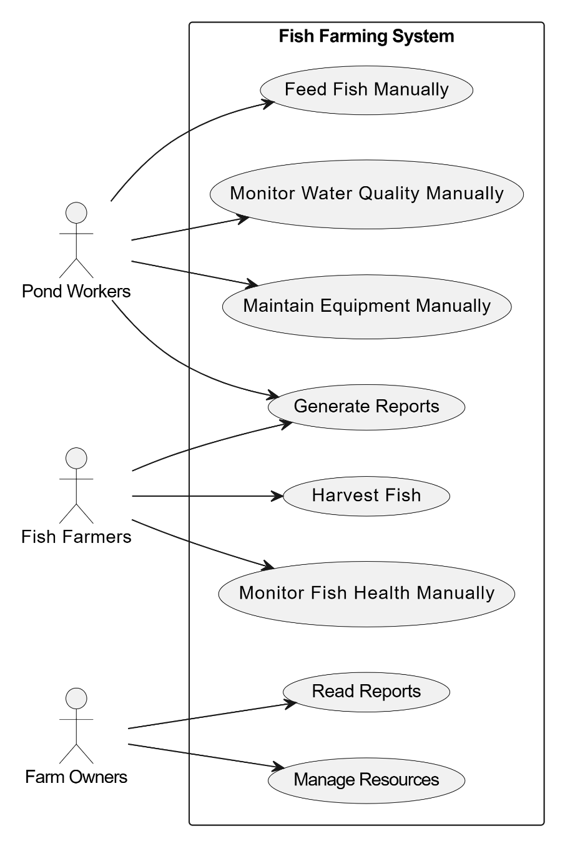

The above use case diagram illustrates the traditional current interactions between key operators (Farm Workers (Pond Workers), and the Farm Owners) and the Fish Farming Pond at Zimunda Estate. Pond Workers are responsible for tasks such as feeding fish, monitoring water quality, and maintaining equipment. Fish Farmers oversee activities related to harvesting fish and monitoring fish health. Both pond workers and the fish farmers are responsible for generating reports of all their operations. Farm Owners manage resources, read reports and oversee the overall operation of the fish farming system.

## **Fig 3.2: Existing Activity Diagram**

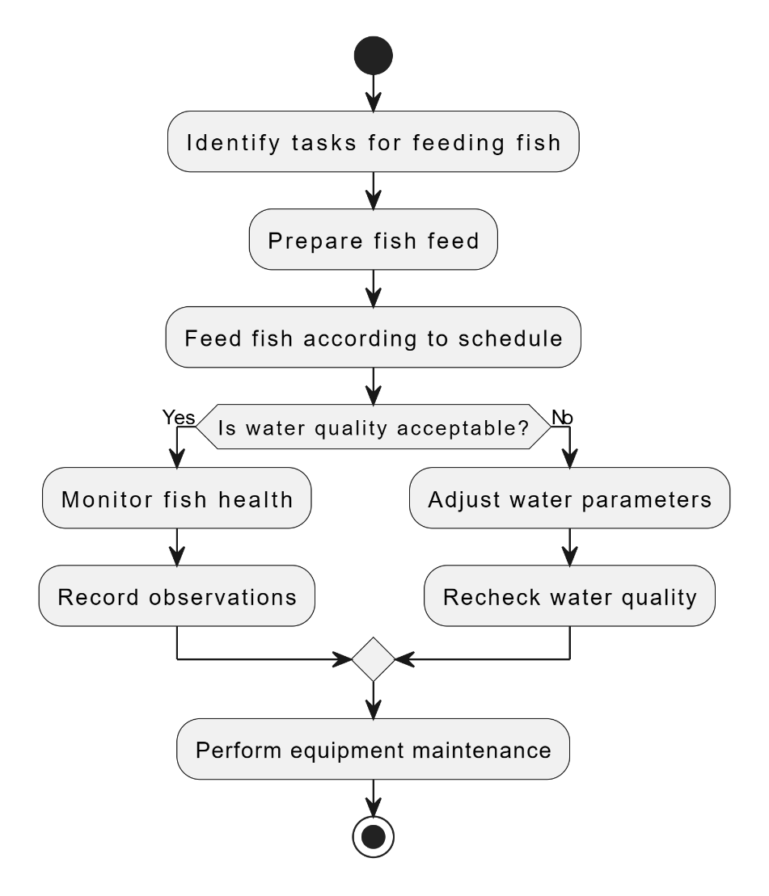

The activity diagram outlines the sequential steps involved in the daily operations of fish farming at Zimunda Estate. Farm workers identify tasks for feeding fish and prepare the fish feed accordingly. They then feed the fish according to the predetermined schedule. If the water quality is acceptable, fish health is monitored, and observations are recorded. If the water quality is not acceptable, adjustments are made to water parameters, and water quality is rechecked, and this is all done manually by the farm workers. Additionally, routine equipment maintenance is performed to ensure smooth operation.

## **Fig 3.3: Existing Sequence Diagram**

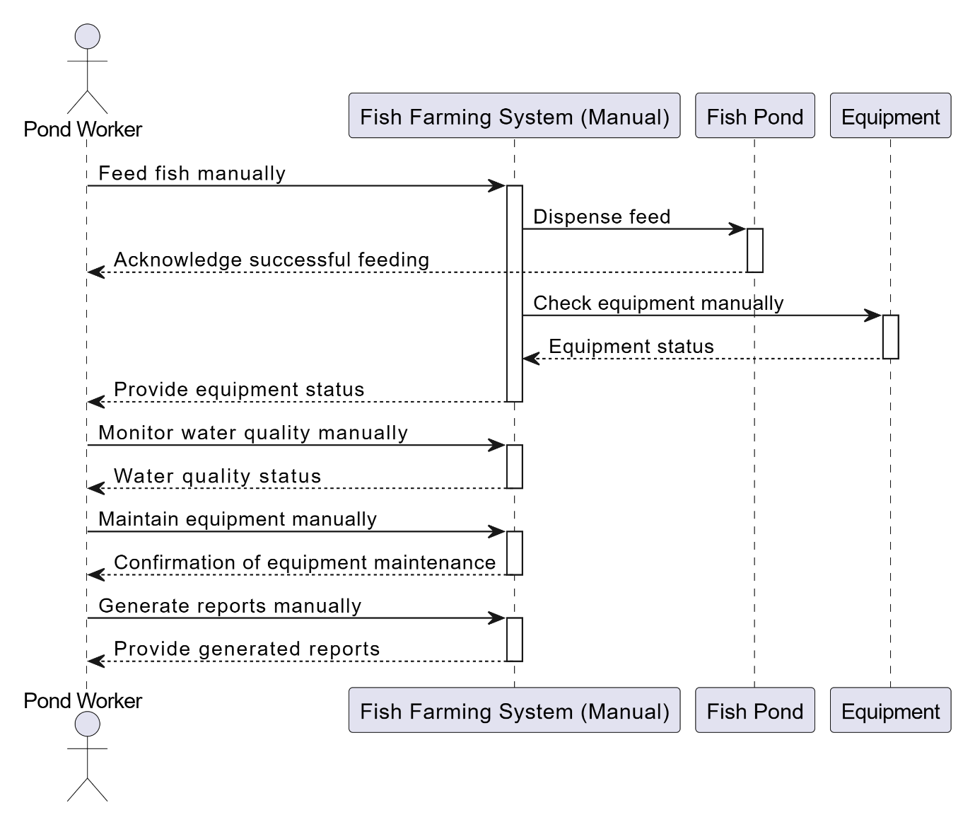

The sequence diagram demonstrates the manual nature of operations within Zimunda Estate's fish farming system. Pond Workers manually handle tasks like feeding fish, monitoring water quality, maintaining equipment, and generating reports. They initiate feeding, monitor water quality, conduct equipment maintenance, and generate reports manually. Feedback on successful feeding, water quality status, equipment maintenance, and generated reports is provided by the Fish Farming System (Manual) to Pond Workers. This manual approach highlights the reliance on human labour for essential farm operations and underscores the potential for improvement through automation.

## **3.3 EVALUATION OF ALTERNATIVES TO THE CURRENT SYSTEMS**

In evaluating alternatives to the current manual fish farming system at Zimunda Estate, two primary options are considered: adopting an off-the-shelf system and transitioning to a fully automated system.

## **Off-the-Shelf System:**

An off-the-shelf system refers to pre-built software or hardware solutions readily available in the market. These systems are designed to address common needs and are typically accessible to a wide range of users. Implementing an off-the-shelf system involves selecting a solution that best aligns with the farm's requirements and deploying it without extensive customization.

*Advantages:*

* Accessibility: Off-the-shelf systems are readily available and can be quickly implemented, minimizing development time.
* Scalability: Many off-the-shelf systems are scalable, allowing for future expansion and adaptation as farm needs evolve.

*Disadvantages:*

* Limited Customization: Off-the-shelf systems may lack customization options, limiting their suitability for specific farm requirements.
* Dependency on Vendor: Reliance on third-party vendors for support and updates may result in potential service disruptions or compatibility issues.
* High Cost: These systems often cost significantly high compared to custom-built alternatives, reducing making them much expensive.

## **Fully Automated System:**

A fully automated system involves the integration of advanced technologies such as sensors, actuators, and control systems to automate various aspects of fish farming operations. In a fully automated system, tasks such as feeding fish, monitoring water quality, and controlling equipment are performed autonomously without direct human intervention.

*Advantages:*

* Precision and Efficiency: Fully automated systems offer precise control over fish farming processes, optimizing feed distribution, water quality management, and equipment operation.
* Labor Savings: Automation reduces dependency on manual labour, minimizing operational costs associated with staffing and human error.
* Data-Driven Decision-Making: Automated systems collect real-time data, enabling informed decision-making and proactive management of farm operations.

*Disadvantages:*

* Initial Investment: Transitioning to a fully automated system requires significant upfront investment in technology and infrastructure.
* Technical Complexity: Implementing and maintaining automated systems may require specialized technical expertise, potentially posing challenges for farm staff.

While both options offer distinct advantages, the fully automated system emerges as the optimal choice for Zimunda Estate. Despite the initial investment and technical complexities, the long-term benefits of precision, efficiency, and labour savings outweigh the drawbacks. By embracing automation, Zimunda Estate can enhance productivity, maximize resource utilization, and position itself as a leader in sustainable and technologically advanced fish farming practices.

## **3.4 SUMMARY:**

On the analysis phase of the project, we focused on the information gathering techniques and the evaluation of alternatives to the current manual fish farming system at Zimunda Estate. Through face-to-face interviews, insights were gained from stakeholders, including pond workers and farm owners, shedding light on the intricacies of the existing system and the challenges faced. Additionally, site visits to other farms provided valuable firsthand observations and comparisons. The chapter also presented diagrams illustrating the current manual processes, emphasizing the need for improvement. Furthermore, the evaluation of alternatives highlighted the potential benefits and drawbacks of leveraging off-the-shelf systems versus transitioning to fully automated solutions. This comprehensive analysis lays the groundwork for informed decision-making and sets the stage for the subsequent phases of the project, aiming to revolutionize fish farming practices at Zimunda Estate.

# **CHAPTER 4:** DESIGN PHASE

Here we delve into the design phase of the Smart project, where the focus shifts towards analysing the new system's architecture and interface design. This phase entails the creation of various UML diagrams, including use case diagrams and activity diagrams, to enhance the current manual system used by students and staff at Zimunda Estate. The chapter emphasizes the importance of these UML diagrams in visualizing system functionalities and interactions. Additionally, it explores the intricacies of interface design, aiming to create user-friendly interfaces that facilitate seamless interaction with the system. Furthermore, architectural design considerations are addressed to ensure scalability, reliability, and efficiency of the new system. Through meticulous planning and design, this chapter sets the foundation for the implementation phase, bringing the vision of an advanced and efficient farming system at Zimunda Estate one step closer to reality.

## **4.2 ANALYSIS OF THE NEW SYSTEM**

## **Fig 4.1 New System Use Case Diagram:**

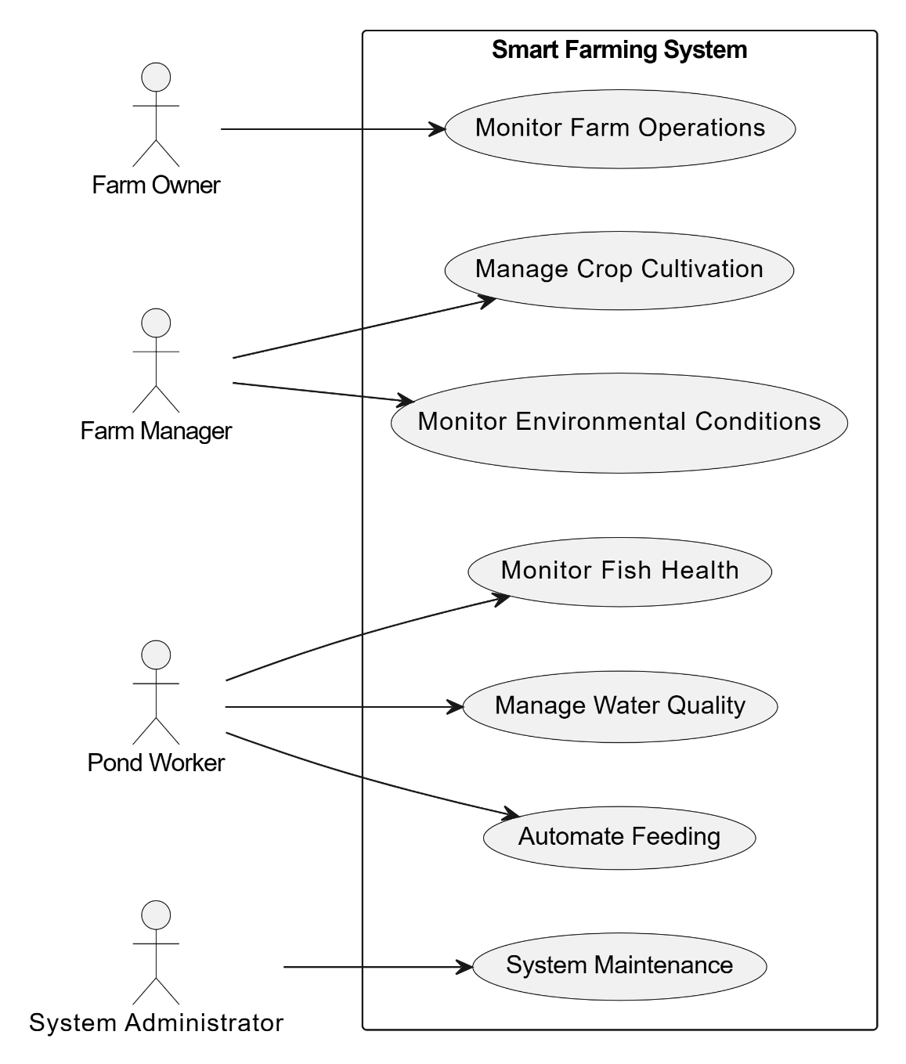

The use case diagram presents an intricate network of interactions within the Aquaponics-Integrated Smart Farming System at Zimunda Estate, involving multiple actors with diverse roles and responsibilities. Farm Owner, Farm Manager, Pond Worker, and System Administrator engage with various system functionalities tailored to their specific tasks. The diagram highlights the system's versatility in catering to the needs of different stakeholders, from overseeing farm operations and managing crop cultivation to monitoring environmental conditions, fish health, water quality, and system maintenance.

## **Fig 3.2 New System Activity Diagram:**

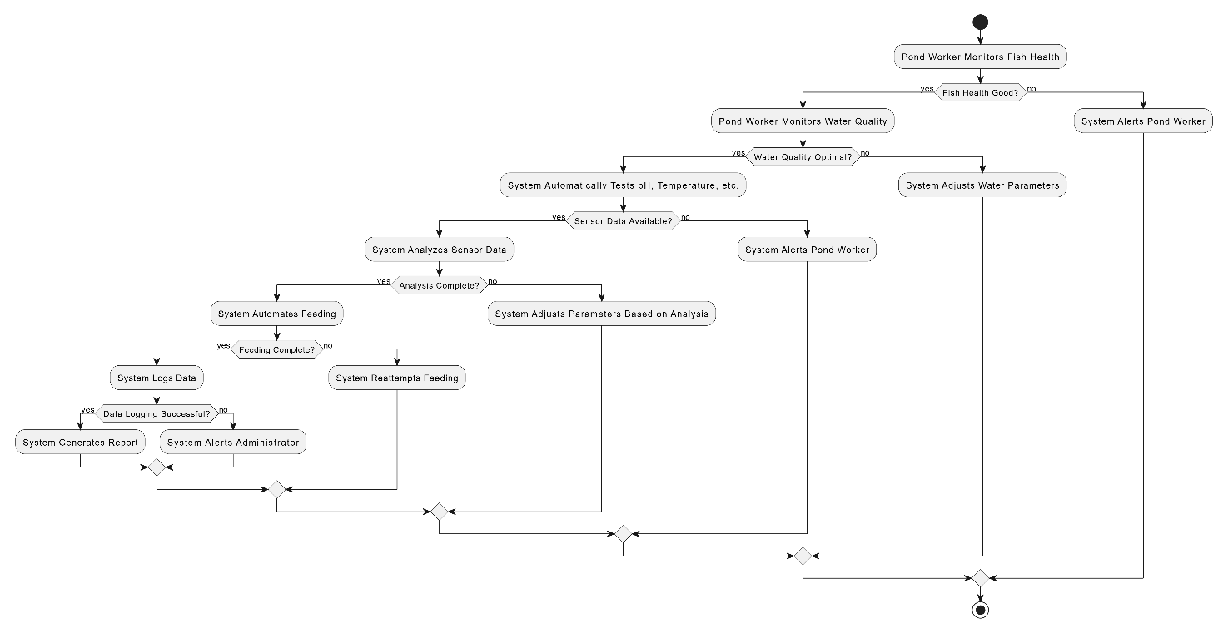

The activity diagram illustrates the intricate processes of the Smart Automated Fish Farming Pond System at Zimunda Estate. After the Pond Worker monitors fish health and water quality, the system automatically tests parameters such as pH, temperature, and others using sensors. Upon receiving sensor data, the system analyses it to determine the appropriate actions. If conditions are favourable, the system automates feeding. Subsequently, the system logs data, generates reports, or adjusts parameters based on the analysis. In case of any issues or anomalies, the system alerts the Pond Worker or Administrator for further intervention. This complex flow showcases the advanced capabilities of the smart automated fish farming pond system, enabled by sensor technology and autonomous decision-making processes.

## **Fig 3.3 New System Sequence Diagram:**

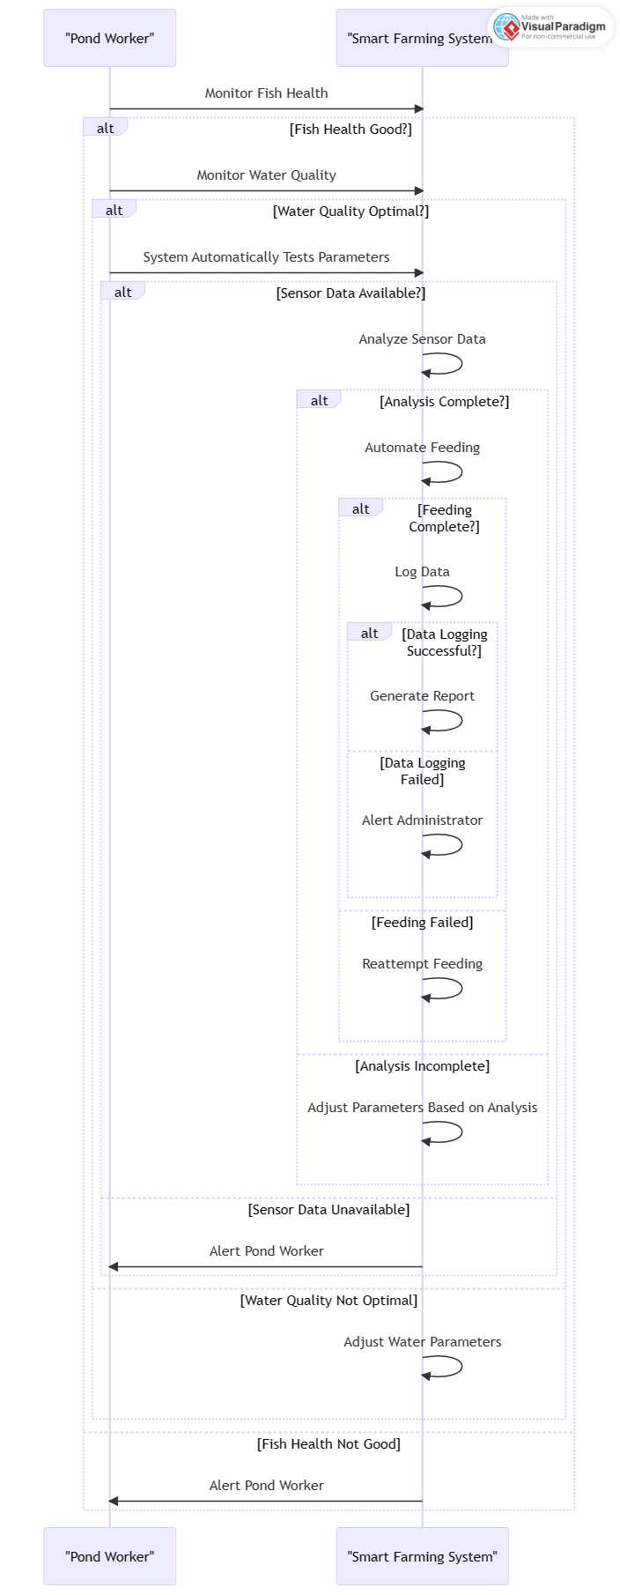

The sequence diagram illustrates the interactions between the Pond Worker and the Aquaponics-Integrated Smart Farming System in the context of automated fish farming at Zimunda Estate. The Pond Worker begins by monitoring fish health. If the fish health is good, the Pond Worker proceeds to monitor water quality. If the water quality is optimal, the Aquaponics-Integrated Smart Farming System automatically tests parameters such as pH and temperature using sensors. Upon receiving sensor data, the system analyses it. Depending on the analysis, the system may automate feeding, log data, generate reports, or adjust parameters. In case of any issues or anomalies, the system alerts the Pond Worker for further action. This sequence demonstrates the complex workflow of the smart automated fish farming system, driven by sensor technology and autonomous decision-making processes.

## **4.2 FUNCTIONALITY OF THE PROPOSED SYSTEM**

## **4.2.1 FUNCTIONAL REQUIREMENTS**

Functional requirements for the Aquaponics-Integrated Smart Farming System at Zimunda Estate outline the intended functions necessary for its operation:

1. Allow farm workers to log in.
2. Enable system administrators to log in.
3. Allow farm workers to monitor key water parameters such as pH, temperature, and oxygen levels.
4. Provide a feature for scheduling automated feeding times and quantities based on fish species and growth stage.
5. Allow farm workers to adjust environmental factors such as water flow, aeration, and lighting to optimize fish growth and health.
6. Provide real-time monitoring of equipment status such as pumps, filters, and aerators to ensure proper functioning.
7. Allow administrators to generate reports on key performance indicators such as fish growth rates, feed conversion ratios, and water quality trends.
8. Implement an alert system to notify farm workers and administrators of any anomalies or system malfunctions requiring attention.

## **4.2.2 NON-FUNCTIONAL REQUIREMENTS**

Non-functional requirements focus on system attributes such as reliability, efficiency, and usability:

1. Ensure that the system can handle a large volume of data without significant slowdowns or performance issues.
2. Design the system with a user-friendly interface that is intuitive and easy to navigate for farm workers with varying levels of technical expertise
3. Ensure compatibility with all Windows computers.
4. Ensure that the system can accommodate increases in the number of users, fish tanks, and data storage requirements without compromising performance.
5. Implement backup and recovery mechanisms to ensure that data integrity is maintained in the event of system failures or disruptions.
6. Ensure compatibility with industry-standard protocols and formats for seamless integration with existing hardware and software systems used in fish farming operations.

## **4.2.3 SYSTEM CONSTRAINTS**

The Aquaponics-Integrated Smart Farming System at Zimunda Estate faces several constraints that may impact its development and functionality:

1. **Cost**:
   * Development costs, including hardware, software, and implementation expenses, must be carefully managed within budget constraints to ensure the project remains financially viable.
   * Ongoing maintenance and support costs should also be considered to sustain the system over its lifecycle.
2. **Scope**:
   * The scope of the project must be clearly defined to prioritize essential features and functionalities aligned with Zimunda Estate's fish farming requirements.
   * Any additional features or enhancements beyond the defined scope should be carefully evaluated to avoid scope creep and maintain project focus.
3. **Time**:
   * Development timeframes are limited, requiring efficient project management and prioritization of tasks to meet project milestones and deadlines.
   * Delays in development or unforeseen challenges may impact the project schedule, necessitating proactive risk management and contingency planning.
4. **Resource Availability**:
   * Availability of skilled personnel, both internally and externally, may pose a constraint on the project's execution.
   * Adequate resources, including human resources, infrastructure, and equipment, must be allocated to support system development and implementation activities.

## **4.3 ERD / TABLES**

## **Fig 4.5 Smart Farm ERD**

ENTITIES AND ATTRIBUTES

**Entity Attributes**

* **Farm Admin**: *admin_id (PK),* username, password, email, contact_number
* **Farm Worker**: *worker_id (PK****),*** name, role, contact_number, email
* **Pond**: *pond_id (PK****),*** location, capacity, water_quality, temperature, pH_level, dissolved_oxygen_level
* **Sensor:** *sensor_id (PK),* type, location, status, current_reading

RELATIONSHIPS

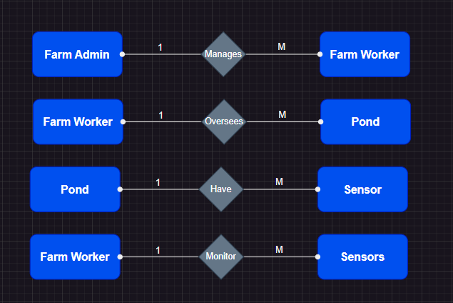

ENTITY RELATIONAL DIAGRAM

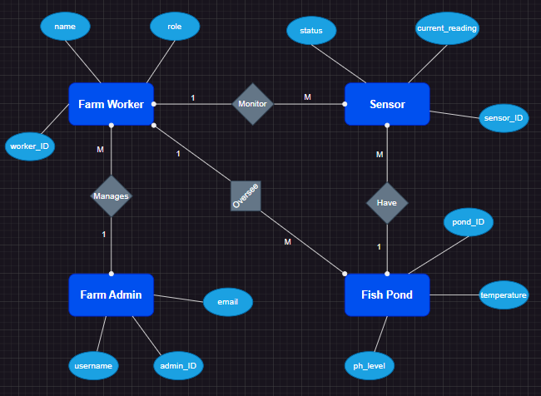

## Table 4.1 Farm Administrator table:

|  |  |  |  |
| --- | --- | --- | --- |
| Field Name | Data Type | Size | Description |
| admin_id | int | 5 | Primary key for admin |
| username | varchar | 20 | Username for login |
| password | varchar | 50 | Password for login |
| email | varchar | 50 | Email address of admin |
| contact_number | number | 10 | Contact number of admin |

## Table 4.2 Farm Workers table:

|  |  |  |  |
| --- | --- | --- | --- |
| Field Name | Data Type | Size | Description |
| worker_id | int | 5 | Primary key for worker |
| name | varchar | 20 | Name of the worker |
| role | varchar | 20 | Role of the worker |
| contact_number | varchar | 10 | Contact number of worker |
| email | varchar | 50 | Email address of worker |

## Table 4.3 Ponds table:

|  |  |  |  |
| --- | --- | --- | --- |
| Field Name | Data Type | Size | Description |
| pond_id | int | 5 | Primary key for pond |
| location | varchar | 20 | Location of the pond |
| capacity | int | 20 | Capacity of the pond (in litters) |
| water_quality | varchar | 20 | Quality of water in the pond |
| temperature | float | 50 | Temperature of water in the pond |
| pH_level | float | 50 | pH level of water in the pond |
| dissolved_oxygen_level | float | 50 | Dissolved oxygen level in the pond |

## Table 4.4 Sensors table:

|  |  |  |  |
| --- | --- | --- | --- |
| Field Name | Data Type | Size | Description |
| sensor_id | int | 5 | Primary key for sensor |
| type | varchar | 50 | Type of sensor |
| location | varchar | 20 | Location of the sensor |
| status | varchar | 20 | Status of the sensor |
| Current_reading | Number | 50 | Current reading from the sensor |

## **Fig 4.4 CLASS DIAGRAM**

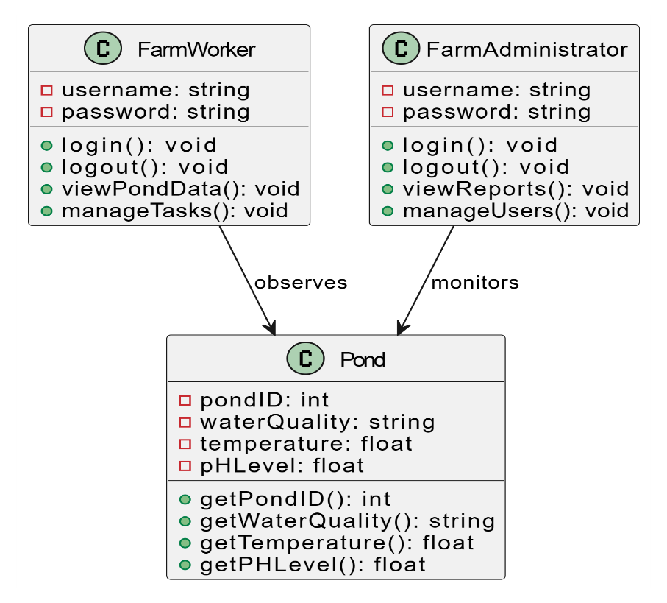

This diagram represents the main classes involved in the system, including **FarmWorker**, **FarmAdmin**, **Pond**, and **Sensor**, along with their attributes and relationships.

## **4.5 MAIN SCREEN AND INTERFACE DESIGN**

The main interface design for the Smart Fish Farming System at Zimunda Estate have been crafted to provide intuitive navigation and easy access to various functionalities. The menu structure is designed to streamline user interactions and ensure efficient management of the fish farming operations. Key sections include:

1. **Dashboard**: Provides an overview of essential metrics and real-time data regarding pond conditions, fish stock, errors and sensor readings.
2. **Pond Management**: Allows farm workers and admin to view and manage information related to individual ponds, including water quality, temperature, pH levels, and fish stock.
3. **Sensor Monitoring**: Enables users to monitor the status and readings of sensors installed in different locations across the farm, facilitating proactive maintenance and troubleshooting.
4. **Reports and Analytics**: Offers comprehensive reports and analytics on fish growth, pond conditions, and operational efficiency, empowering informed decision-making and strategic planning.

## **4.6 INTERFACE DESIGN**

A good interface design of the Aquaponics-Integrated Smart Farming System of Zimunda Estate should:

* **Be easy to use for different types of users**: The interface prioritizes simplicity and intuitiveness, featuring clear navigation menus and user-friendly controls. Farm workers can easily access essential functionalities without extensive training, enhancing productivity and reducing the learning curve.
* **Have a visual clarity**: The interface employs a clean and uncluttered layout, ensuring that critical information and actionable insights are presented prominently. Clear visual indicators and color-coded elements to facilitate quick comprehension and decision-making.
* **Have Role-Based Access Features:** Different user roles, such as farm workers, administrators, and farm owners, are assigned tailored interfaces with access to relevant features and data. This role-based access control ensures that users only see information pertinent to their responsibilities, enhancing security and data privacy.
* **Be able to provide Real-Time Updates**: real-time data streaming and dynamic content updates to provide users with the most current information on pond conditions, sensor readings, and task statuses.
* **Have a Responsive Design:** the interface is designed to adapt seamlessly to various devices and screen sizes, including desktop computers, tablets, and mobile phones. This responsiveness ensures consistent user experiences across different platforms, enabling farm workers to access critical information from any location on the farm.

## **4.7 SECURITY DESIGN (Physical, Network, And Operational)**

In adherence to the principle of "security by design," our Aquaponics-Integrated Smart Farming System at Zimunda Estate implements robust measures across physical, network, and operational domains to mitigate risks and ensure data integrity.

## **4.7.1 Physical Security Design**

Physical security measures include security guards, surveillance cameras, motion sensors, external backups, well-lit areas, fencing, and robust locking systems to safeguard our server rooms and prevent unauthorized access or tampering of the main system.

## **4.7.2 Network Security**

Network security encompasses firewalls, access controls, and email security protocols to defend against breaches, intrusions, and data threats, ensuring the integrity and confidentiality of our system's network and data.

## **4.7.3 Operational Security**

Operational security focuses on user interaction safeguards, such as authentication mechanisms for validating user credentials, ensuring only authorized personnel can access and operate the system securely.

## **4.8 ALGORITHM DESIGN**

Our Aquaponics-Integrated Smart Farming System employs multiple algorithms to ensure efficient and seamless operation. The primary algorithms include the sensor data fetching algorithm, real-time weather data fetching algorithm, error detection and notification algorithm, periodic report generation algorithm, and the automated report emailing algorithm.

## **4.8.1 Sensor Data Fetching Algorithm**

This algorithm is responsible for collecting data from various sensors in the system and storing it in the Firebase database. The steps involved are as follows:

1. **Initialization:**
   * Initialize the microcontroller and connect to the sensors.
   * Establish a connection to the Firebase database.
2. **Main Loop:**
   * Continuously monitor sensor data.
3. **Data Acquisition:**
   * Collect data from sensors (e.g., pH, temperature, humidity).
4. **Data Validation:**
   * Check the collected data for errors or noise.
5. **Data Transmission:**
   * Send validated data to the Firebase database for storage.

## **4.8.2 Real-Time Weather Data Fetching Algorithm**

This algorithm fetches real-time weather data using the OpenWeather API to help farmers make informed decisions based on current weather conditions. The steps involved are:

1. **Initialization:**
   * Set up the API connection and configure API keys.
2. **Data Request:**
   * Send a request to the OpenWeather API for current weather data.
3. **Data Reception:**
   * Receive the response from the API.
4. **Data Processing:**
   * Parse the weather data to extract relevant information.
5. **Data Storage:**
   * Store the processed weather data in the Firebase database.

## **4.8.3 Error Detection and Notification Algorithm**

This algorithm detects system errors and sends notifications to the dashboard, as well as via SMS, WhatsApp, or email. The steps involved are:

1. **Initialization:**
   * Initialize error detection protocols and notification settings.
2. **Continuous Monitoring:**
   * Continuously monitor system performance and sensor data.
3. **Error Detection:**
   * Identify anomalies or errors in the system.
4. **Notification Trigger:**
   * Trigger notifications for detected errors.
5. **Message Dispatch:**
   * Send error notifications to the dashboard and via SMS, WhatsApp, or email.

## **4.8.4 Periodic Report Generation Algorithm**

This algorithm automatically generates periodic reports based on the collected data and converts them into PDF format. The steps involved are:

1. **Initialization:**
   * Set up report generation parameters and schedule.
2. **Data Compilation:**
   * Gather data from the Firebase database.
3. **Report Creation:**
   * Compile the data into a structured report format.
4. **PDF Conversion:**
   * Convert the report into a PDF file.
5. **Storage:**
   * Save the PDF report in the system.

## **4.8.5 Automated Report Emailing Algorithm**

This algorithm sends the generated periodic reports to the admin or farm manager via email every week. The steps involved are:

1. **Initialization:**
   * Configure email settings and recipient details.
2. **Report Scheduling:**
   * Schedule weekly report generation.
3. **Email Preparation:**
   * Attach the generated PDF report to an email.
4. **Email Dispatch:**
   * Send the email to the admin or farm manager.
5. **Confirmation:**
   * Log the email dispatch status and confirm successful delivery.

## **4.8 SUMMARY**

This chapter delves into the detailed design aspects of our Aquaponics-Integrated Smart Farming System. It elaborates on the UML diagrams used in system analysis, including the use case, activity and sequence diagrams. Functional and non-functional requirements are identified, alongside diagrams like ERD, essential for database design. Class diagrams and relationships are clarified, offering insights into system architecture. Lastly, the chapter comprehensively addresses the three layers of security, network, operational, and physical highlighting the researchers commitment to system integrity and data protection.

# **CHAPTER 5:** IMPLEMENTATION

## **5.1 SYSTEM IMPLEMENTATION**

The implementation phase involves converting the design specifications into actual code and hardware setups. This chapter details the steps taken to implement the Aquaponics-Integrated Smart Farming System at Zimunda Estate, including both software and hardware components.

## **5.1.1 SOFTWARE IMPLEMENTATION**

The software components of the system were developed using a combination of Python for backend processing and Firebase for real-time database management. Key functionalities such as sensor data fetching, weather data integration, error detection, and report generation were implemented through well-defined algorithms.

### Fig 1.1: User Login Interface

Login screenshot

*Description: The Create Account screen for the system where the admin create an account to access the system.*

Signup screenshot

*Description: The login screen for the system where the admin authenticate to access the dashboard.*

### Fig 1.2: Home Overview

Home screenshot

*Description: The homepage shows a welcome message, several cards like for the dashboard, Real-time weather monitoring and messages and notifications.*

### Fig 1.3: Dashboard Overview

*Description: The main dashboard displaying real-time sensor data, system status, uptime, latest reading time and other more* ***useful*** *data to the admin or manager.*

### Fig 1.4: Real-Time Weather Data card

Weather card

*Description: Integration of real-time weather data fetched from the OpenWeather API.*

### Fig 1.4: Real-Time Weather Data Overview

Weather modal

*Description: Integration of real-time weather data fetched from the OpenWeather API.*

### Fig 1.5: Error Notification Interface

Notifications panel

*Description: The interface showing error notifications sent by the system.*

### Fig 1.6: Sensor Data Overview

Sensor data page

*Description: Interface to see the complete overview of the sensors and pumps.*

### Fig 1.7: Report Generation Interface

Report page

*Description: Interface for generating and viewing periodic reports.*

## **5.2 HARDWARE IMPLEMENTATION**

The hardware components include sensors (pH, temperature, humidity), microcontrollers, and actuators. These were strategically installed in the pond to monitor and control the aquaponics environment.

### Figure 1.8: Sensors, actuators and the Microcontroller (Raspberry Pi)

The whole system connected

*Description: Installation of sensors and pumps to monitor water quality, The microcontroller setup that processes sensor data and communicates with the Firebase database.*

## **5.3 TESTING**

Testing ensures the system meets all specified requirements and functions correctly. The testing phase included unit testing, module testing, acceptance testing, validation, and verification.

### 5.2.1 UNIT TESTING

At this level, individual components of the software were tested to ensure they functioned correctly. Each unit, such as a sensor data fetching function, was tested separately.

### Fig 1.9: Unit Test Results

Temperature sensor screenshots

*Description: Results of unit tests conducted on sensor data fetching functions.*

### 5.3.2 MODULE TESTING

Module testing involved testing specific modules like the error detection and notification module. This ensured each module worked correctly within the larger system.

### Fig 2.0: Module Test Results

*Description: Results of module tests conducted on the error detection and notification system.*

### 5.3.4 VALIDATION

Validation ensured the system met high-level requirements and was the correct product. This included dynamic testing activities such as unit testing, white box testing, integration testing, and black box testing. Our system implementation prioritizes security measures, including password encryption, validation of email addresses and passwords, and user authentication. Screenshots demonstrate these security implementations in action.

### Fig 2.1: Validation Test Results

Login validation

*Description: Results of validation tests ensuring the system meets all specified requirements.*

### 5.1 SYSTEM SECURITY

Our system implementation prioritizes security measures, including password encryption, validation of email addresses and passwords, and user authentication. Screenshots demonstrate these security implementations in action.

firebase database security details screenshot

### 5.3.5 VERIFICATION

Verification confirmed that the system accomplished its objectives without errors. This involved static testing methods such as inspections, reviews, walkthroughs, and desk-checking.

### 5.3.3 ACCEPTANCE TESTING

The system was evaluated to ensure it met business requirements and was ready for deployment. This included testing the overall integration of software and hardware components.

## **5.4 SYSTEM IN ACTION**

Finally, the integrated system was tested in a real-world scenario at Zimunda Estate. The following images and figures illustrate the system in operation.

### Figure 5.4: System Monitoring Pond Environment

The whole system running

*Description: The system actively monitoring and adjusting the pond environment at Zimunda Estate.*

### Figure 5.5: Real-Time Data Display

Realtime weather modal

*Description: Real-time display of sensor data on the system dashboard.*

# **CHAPTER 6:** SUMMARY AND CONCLUSION

## **6.1 INTRODUCTION**

The aim of this project was to develop an Aquaponics-Integrated Smart Farming System for Zimunda Estate, addressing the limitations of the current manual fish farming practices. This system leverages modern technology to enhance efficiency, sustainability, and productivity. Throughout the project, various phases including planning, analysis, design, implementation, and testing were meticulously executed. This chapter summarizes the key points from each phase and discusses the significance, challenges, and future recommendations of the project.

## **6.2 SUMMARY OF CHAPTERS**

This project encompassed six comprehensive chapters, each detailing a critical phase in the development of the smart farming system:

* **Chapter 1: Introduction** - Provided an overview of Zimunda Estate's current fish farming practices, identified the challenges associated with the manual system, and highlighted the potential benefits of transitioning to a smart, automated approach.
* **Chapter 2: Planning Phase** - Detailed the planning and preparatory steps, including defining project objectives, scope, and constraints. It also covered the project timeline, resource allocation, and risk management strategies.
* **Chapter 3: Analysis Phase** - Analyzed the requirements for the new system, focusing on the functional and non-functional requirements. It included user needs assessment and the evaluation of alternative solutions to enhance the existing fish farming practices.
* **Chapter 4: Design Phase** - Presented the architectural design of the proposed system, including UML diagrams such as use case, activity, and class diagrams. This chapter also covered interface and database design, ensuring the system's structure supports its intended functionalities.
* **Chapter 5: Implementation and Testing** - Detailed the implementation of the system, including hardware and software integration. It covered the testing methods and results, ensuring the system operates reliably and meets the specified requirements. Screenshots of the software interface and images of the hardware setup were provided.
* **Chapter 6: Summary and Conclusion** - Summarized the project's findings, discussed its significance, addressed the challenges encountered, and provided recommendations for future work.

## **6.3 SIGNIFICANCE OF PROJECT**

This project has made significant contributions to the field of smart farming at Zimunda Estate by introducing an innovative aquaponics-integrated system. The key benefits include:

* **Enhanced Efficiency**: Automation reduces manual labour and optimizes resource management, leading to higher productivity.
* **Improved Data Accuracy**: Accurate real-time data collection and analysis help maintain optimal conditions for fish and plants.
* **Proactive Management**: Automated alerts enable timely interventions, preventing potential issues.
* **Sustainability**: The system promotes sustainable farming practices by optimizing resource use and reducing waste.

## **6.5 OBJECTIVES MET:**

* Designed and developed a comprehensive smart farming system tailored to Zimunda Estate's needs.
* Achieved an automated Zimunda aquaponics web system, providing efficient monitoring and management of the farm.
* Implemented a GPS-based weather forecasting subsystem within the Zimunda system, enabling informed decision-making and proactive responses to weather patterns.
* Developed a notifications system that delivers alerts and warnings about various parameters, such as low water level, high or low temperature, and high or low pH levels of the pond water. The notifications are integrated into the web system and can be delivered via WhatsApp and SMS, allowing the admin user to choose the most suitable method.
* Made the system accessible on the web, enabling access from a wide range of devices with internet connectivity and a browser. The system can be managed remotely from any device across the internet.

## **6.6 CHALLENGES ENCOUNTERED:**

* Integrating diverse hardware components required careful planning and execution.
* Ensuring consistent and accurate data collection from sensors was critical for system reliability.
* Addressing network connectivity and data transmission issues, especially in remote areas.
* Only managed to develop the web application due to time constraints; the mobile app was not completed.
* Faced budget constraints that prevented the acquisition of necessary components like the pH sensor and a 3D printer for enclosure fabrication.
* Many required APIs were paid services, adding to the project cost; this included features for WhatsApp or SMS notifications through services like Twilio.

## **6.7 RECOMMENDATIONS AND FUTURE WORK**

To improve implementation and adoption of the smart farming system at Zimunda Estate:

* **Conducting Extensive Field Trials**: Validating the system's effectiveness in various conditions and operational scenarios.
* **Collaborating with Agricultural Experts**: Refining the system based on practical feedback and best practices.
* **Regularly Update the System**: Incorporating technological advancements and user feedback to enhance functionality and performance.

**FUTURE WORK:**

* **Explore Additional Sensors**: Incorporating more sensors for comprehensive monitoring, such as nutrient levels in water and fish health indicators.
* **Develop Mobile Applications**: Creating mobile apps for remote monitoring and control, providing greater flexibility.
* **Investigate Machine Learning Algorithms**: Implementing predictive analytics for proactive management and optimized farming practices.

## **6.8 CONCLUSION**

In conclusion, the Aquaponics-Integrated Smart Farming System developed in this project has the potential to transform fish farming at Zimunda Estate. By leveraging advanced technologies, the system offers a cost-effective, reliable, and efficient solution for managing aquaponics environments. The user-friendly interface and real-time data capabilities enable proactive management and informed decision-making, contributing to higher productivity and sustainability.

This project addresses critical gaps in traditional fish farming practices, offering a scalable and adaptable solution for various farming setups. As we continue to refine and enhance the system, we move closer to achieving a future where smart farming technologies are widely adopted, ensuring sustainable and profitable aquaponics operations.

Future developments and refinements will further enhance the system's capabilities and impact. Through continued innovation and improvement, we aim to enable farmers to achieve better outcomes, reduce environmental impact, and ensure food security. The smart farming system at Zimunda Estate serves as a model for the integration of technology in agriculture, paving the way for more advanced and efficient farming practices globally.

**REFERENCES**

1. Somerville, C., Cohen, M., Pantanella, E., Stankus, A., & Lovatelli, A. (2014). Small-scale aquaponic food production: Integrated fish and plant farming. FAO Fisheries and Aquaculture Technical Paper No. 589. Rome, FAO.
2. Rakocy, J. E., Masser, M. P., & Losordo, T. M. (2006). Recirculating aquaculture tank production systems: Aquaponics—Integrating fish and plant culture. SRAC Publication No. 454.
3. Love, D. C., Fry, J. P., Li, X., Hill, E. S., Genello, L., Semmens, K., & Thompson, R. E. (2015). Commercial aquaponics production and profitability: Findings from an international survey. Aquaculture, 435, 67-74.
4. Goddek, S., Joyce, A., Kotzen, B., & Burnell, G. (Eds.). (2019). Aquaponics Food Production Systems: Combined Aquaculture and Hydroponic Production Technologies for the Future. Springer Nature.
5. Resh, H. M. (2012). Hydroponic Food Production: A Definitive Guidebook for the Advanced Home Gardener and the Commercial Hydroponic Grower. CRC Press.
6. Tyson, R. V., Simonne, E. H., Treadwell, D. D., Davis, M., & White, J. M. (2008). Effect of water pH on yield and quality of salad greens in a floating hydroponic system. HortScience, 43(3), 893-897.
7. Nelson, R. L. (2008). Aquaponic Food Production: Raising Fish and Plants for Food and Profit. Nelson & Pade Multimedia.
8. Lennard, W. A. (2017). Aquaponics: The integration of fish and hydroponic plant production. In Soilless Culture: Theory and Practice (pp. 127-160). Elsevier.
9. Blidariu, F., & Grozea, A. (2011). Increasing the economical efficiency and sustainability of indoor fish farming by means of aquaponics-review. Scientific Papers Animal Science and Biotechnologies, 44(2), 1-8.
10. Kloas, W., Groß, R., Baganz, D., Bischoff, A., Börnick, H., Pennekamp, J., & Schmidt, U. (2015). A new concept for aquaponic systems to improve sustainability, increase productivity, and reduce environmental impacts. Aquaculture Environment Interactions, 7(2), 179-192.
11. Pantanella, E. (2012). Aquaponics: a promising aquaculture technology for water quality and waste management. In Proceedings of the International Symposium on the Role of Plant Genetic Resources in Reclaiming Lands and Environment Deteriorated by Human and Natural Actions.
12. DeLong, D. P., Losordo, T. M., & Rakocy, J. E. (2009). Tank Culture of Tilapia. SRAC Publication No. 282.
13. Timmons, M. B., & Ebeling, J. M. (2013). Recirculating Aquaculture. Cayuga Aqua Ventures.
14. Somerville, C. (2017). Aquaponics: Enhancing the Health and Quality of Food in Urban, Peri-urban, and Rural Communities. Springer Briefs in Geography.
15. Delaide, B., Monsees, H., Gross, A., Goddek, S., & Vermeulen, T. (2021). Techno-economic and environmental assessment of a commercial aquaponic system for urban farming. Agricultural Systems, 193, 103210.
16. Mariscal-Lagarda, M. M., Páez-Osuna, F., Guerrero-Monroy, I., & Leal-Ramos, L. (2012). Aquaponics: an alternative to sustainable agriculture in semi-arid regions. Environmental Science and Pollution Research, 19, 2365-2373.
17. Adler, P. R., Takeda, F., Glenn, D. M., & Summerfelt, S. T. (2000). Aquaponic production of tilapia and basil: Comparing a batch and staggered cropping system. Aquacultural Engineering, 21(2), 97-108.
18. Graber, A., & Junge, R. (2009). Aquaponic systems: nutrient recycling from fish wastewater by vegetable production. Desalination, 246(1-3), 147-156.
19. Rakocy, J. E., Bailey, D. S., Shultz, R. C., & Danaher, J. J. (2003). Preliminary evaluation of organic waste from two aquaculture systems as a source of inorganic nutrients for hydroponics. Acta Horticulturae, 648, 219-226.
20. Danaher, J. J., Shultz, R. C., Rakocy, J. E., & Bailey, D. S. (2013). Alternative solids removal techniques for aquaponic systems. In Aquaculture: New Techniques and Applications (pp. 1-12). Nova Science Publishers, Inc.
21. Tyson, R. V., Treadwell, D. D., & Simonne, E. H. (2011). Opportunities and challenges to sustainability in aquaponic systems. HortTechnology, 21(1), 6-13.
22. Junge, R., König, B., Villarroel, M., Komives, T., & Jijakli, M. H. (2017). Strategic points in aquaponics. Water, 9(3), 182.
23. Bambridge, L., Chappell, J., & Boyd, C. E. (2005). Designing and operating semi-intensive pond aquaculture systems. Global Aquaculture Advocate, 8(2), 56-59.
24. Vermeulen, T., & Kamstra, A. (2013). The need for systems design for robust aquaponic systems in the urban environment. Acta Horticulturae, 1004, 71-78.
25. Ghamkhar, R., Hicks, A. L., & Hutson, J. (2021). Integrated systems for urban food, energy, and water management: A review of current technologies and future directions. Journal of Environmental Management, 289, 112559.
26. van Gorcum, B., & Meador, J. P. (2021). Evaluating the viability of urban aquaponics in the context of an emerging food movement. Urban Agriculture & Regional Food Systems, 6(1), e20010.
27. Tokunaga, K., Tamaru, C. S., Ako, H., & Leung, P. (2015). Economics of small-scale commercial aquaponics in Hawai'i. Journal of the World Aquaculture Society, 46(1), 20-32.
28. Mohd-Yasin, N. A., Mohd-Noor, S. N., & Johari, A. (2016). Performance of an aquaponics system at different ph levels on the growth of the freshwater prawn, Macrobrachium rosenbergii, and spinach, Amaranthus viridis. International Journal of Agricultural and Biosystems Engineering, 10(12), 859-864.
29. Kyaw, H., Sivasubramaniam, S., & Nielson, B. R. (2014). Fish and plant production in a closed recirculating aquaponic system. Journal of Agricultural Science and Applications, 3(1), 15-20.
30. Wongkiew, S., Hu, Z., Chandran, K., Lee, J. W., & Khanal, S. K. (2017). Nitrogen transformations in aquaponic systems: A review. Aquacultural Engineering, 76, 9-19.